Tie-Up Management

Document Control

Prepared By: | Nandyala Raja Shekar | Designation: | Manager
Date: |  | Signature:
Date |  | Signature

Reviewed By: |  | Designation:
Date: |  | Signature:
Date |  | Signature

Introduction

Purpose
This document is intended to form a basis for the development of Tie-up Management System. This system intends to maintain the various tie-up agreements made with various entities like Corporates, Non-Government institutes, Government Institutes, Insurance Institutes, TPA’s and Internal Hospital Staff entitlements.
These defined entitlements will be integrated with Patient Billing modules and becomes an input for automating the billing calculations for the patients coming from the above tie-up institutes.

Definitions, Acronyms, Abbreviations
S .No | Key Word | Description
1 | MR Number | Same as PIN
2 | TPA | Third Party Associates

Subsystem Description
  - Overview:

- To maintain a database of Corporates, Non-Government institutes, Government Institutes, Insurance Institutes, TPA’s and Internal Hospital Staff for tie-up with the hospital
- To define the following in the institutes entitlements
  - Exceptions
  - Splits
  - Co-payment
  - Limits
  - Inclusions and exclusions
  - Tie up details

  - Functions:

    - New Tie-up
      - Maintain Institutes
      - Authorized Signatories
    - Maintain Institute Agreement
      - Agreement Details
      - Attach Agreement Documents
      - Maintain Check Lists
      - Maintain Sub-Companies (For Insurance)
      - Maintain Insurance Companies (For TPAs)
    - Maintain Tariff
      - Service Tariff
      - Bed Tariff
    - Maintain Institute Wise Service Codes
    - Define Entitlements

Specific Requirements
  - New Tie-up details
    - Institute Details
      - Description
This function captures the new tie-up details and authorized signatories
      - Pre-conditions
None.
      - Main Flow
        - Any new tie-up will be captured in this function.
        - User will enter the Institute details
        - User will indicate the institute is a Corporate or Non-Government institute or Government Institute or Insurance Institute or TPA or Staff.
        - Indicates that the said Institute is OPEN, CONFIRMED, ACTIVE, INACTIVE OR REJECTED.
        - The follow-up details are captured. Whenever any follow-ups are made with the Institute, the details of the same are captured in this tab.
        - The field elements for the above sections are explained below.
      - UI Frame Work For Institute Details

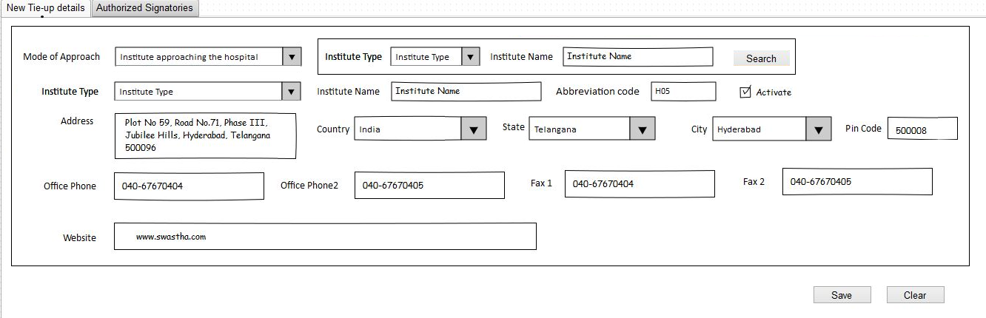

      - Screen Elements For capturing the Institute details

Sl. No. | Field Name | Optional/  Mandatory | Description/  Explanation/  Formulae | Display/Select /Enter (Free text) | Validations | Source (Input) | Remarks (Including Validation)
 | Mode Of Approach | M | Two options for selection the mode of approach to be provided. | Select |  | Mode of approach (System Master) | Example: Institute approaching the hospital.  Hospital approaching the Institute.
 | Institute Type | M | The type of Institute | Select |  | Institute type (System Master) | 1 Corporate  2 TPA  3 Insurance  4 Non-Government  5 Government  6 Staff
 | Institute Abbreviation Code | Nil | Enter | Enter | max length – 5  Allows only alpha-Numeric | Nil | Code should have to check for duplicates and case insensitive
 | Institute Name | M | Name of the Institute | Enter | max length – 50  Should allow special characters. | Nil | The name should have to check for duplicates and case insensitive. If a similar name Institute is created then system to warn the user
 | Status | M | The status of the tie up with the Institute. | Select |  | Status of Tie up (System Master) | User updates the status either to one of the following:  When the Institute is created, the status will be defaulted to OPEN.  If the talks between hospital and Institute are not fruitful then user needs to set the option to REJECTED.  When the MoU is signed, then the status is changed to ACTIVE.  If an tie-up is no more valid with the institute then user can make the Status to IN-ACTIVE
 | Address | M | Address of the Institute | Enter(free text) |  | Nil | Nil
 | Country Name | M | Self Explanatory | Select |  | Country Master | Nil
 | State Name | M | Self Explanatory | Select |  | State Master | Nil
 | City Name | M | Self Explanatory | Select |  | City Master | Nil
 | PIN Code | O | Self Explanatory | Enter | max length,  Only Numeric | Nil | Nil
 | Fax Number 1 | M | Self Explanatory | Enter | max length 15, min length 10  Only Numeric | Nil | Nil
 | Fax Number 2 | O | Self Explanatory | Enter | max length 15, min length 10  Only Numeric | Nil | Nil
 | Office No. -1 | M | Self explanatory | Enter | max length 15, min length 10  Only Numeric | Nil | Nil
 | Office No.- 2 | O | Self Explanatory | Enter | max length 15, min length 10  Only Numeric | Nil | Nil
 | Web Site Name | O | Self Explanatory | Enter | max length 50 | Nil | Nil
 | Search | M | N/A | Button |  | Nil | Should show institutes for all tie up status.

Capture the authorized signatories

Description
The function captures the authorized signatories for the institutes with whom the hospital has signed the MoU.

Pre-conditions
None.

Main Flow
        - Provision should be available to add authorized signatories for the institutes, which are flagged as Active.
        - Provision will be available to capture the scanned signature of the signatory.
        - These signatories should be made visible in the Credit Memo details in Billing modules. User should be able to see the scanned signature.
      - UI Frame Work For Authorized Signatories

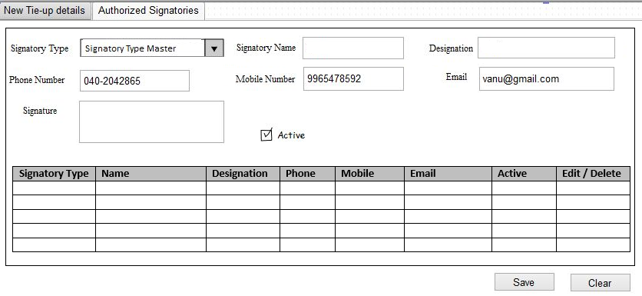

      - Screen Elements For Authorized Signatories

Sr. no. | Field Name | Optional/  Mandatory | Description/  Explanation/  Formulae | Display/Select Enter (Free text) | Validations | Source (Input) | Remarks  (Including Validation)
 | Signatory name | M | Self explanatory | Enter |  | Nil | Nil
 | Designation | M | Designation of the signatory | Enter |  | Nil | Nil
 | Signatory Type | M | Operational, Administration and Payment Related | Select |  | Signatory Type Master (Editable on UI) | User will be select one of the said type from the master
 | Phone Number | O | Phone number of the signatory | Enter | max length 15, min length 10  Only Numeric | Nil | Nil
 | Mobile Number | O | Mobile number of the Signatory | Enter | max length 15, min length 10  Only Numeric | Nil | Nil
 | Email | O | Self explanatory | Enter |  | Nil
 | Signature | O | Self explanatory. | Display | All image formats/pdf | Scanned signature | File Upload
 | Indicator | M | Signatory active /inactive | Select | Default - Yes | Yes/No | Nil
 | Add | M |  | Button |  |  | Save data into database only when user clicks on Add Button

Maintain the Institute Agreement Details

Description
The function maintains all the tie-up related agreement information such as, Agreement references, Agreement documents, checklists and covered companies.

Pre-conditions
The Institute’s tie up status should be Active.

Main Flow
      - The user will select the institutes whose tie-up status is Active.
      - Upon selecting the Institute, system will automatically display the institute details
      - User will be able to
        - Capture Agreement details
        - Attach Any Scanned documents (MoU, Security deposits, bank guarantee etc)
        - Define sub-companies (applicable for the institutes which fall under the type Insurance)
        - Define Insurance Companies (Applicable for the institutes which fall under the type TPA)
        - Check List for the Institute
      - The field elements for the sections are given below.

      - UI Framework for Agreement Details
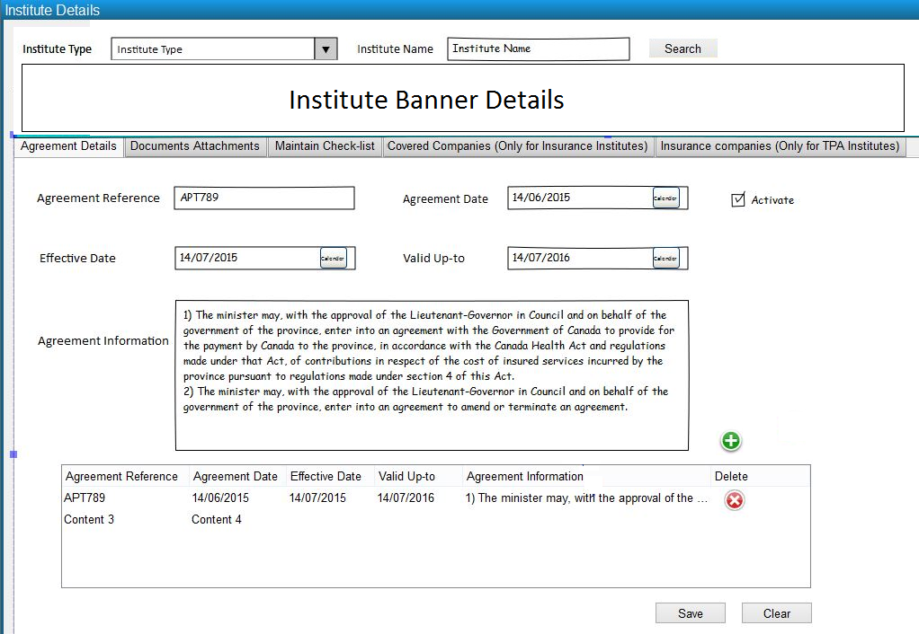

      - Screen Elements For capturing the Agreement Details
Sr. no. | Field Name | Optional/  Mandatory | Description/  Explanation/  Formulae | Display/  Select /Enter | Source (Input) | Remarks  (Including Validation)
 | Institute name | M | The Name of the Institute, for whom the scanned documents are to be attached | Select | Tie up details | Nil
 | Institute code | M | Code for the Institute | Enter | Nil | Nil
 | Agreement Reference | O | Reference number of the agreement. | Enter | Nil | Display in credit memo
 | Agreement Date | M | Date agreement done with the Institute. | Select |  | The date cannot be a future date.
 | Effective Date | M | The agreement effective date | Select | Calendar Master | The date cannot be a future date
 | Valid Up-to | M | Agreement expiry date | Enter | Nil | The date cannot be less than effective date. -default alert
 | Agreement Information | O | Agreement brief notes. | Enter | Nil | Display in the credit memo details.
 | Active Indicator | M | Agreement active /inactive | Select | Yes/No | Nil
 | Print | O | Self explanatory | Select | Nil | Bar code
      - UI Framework for Document Details
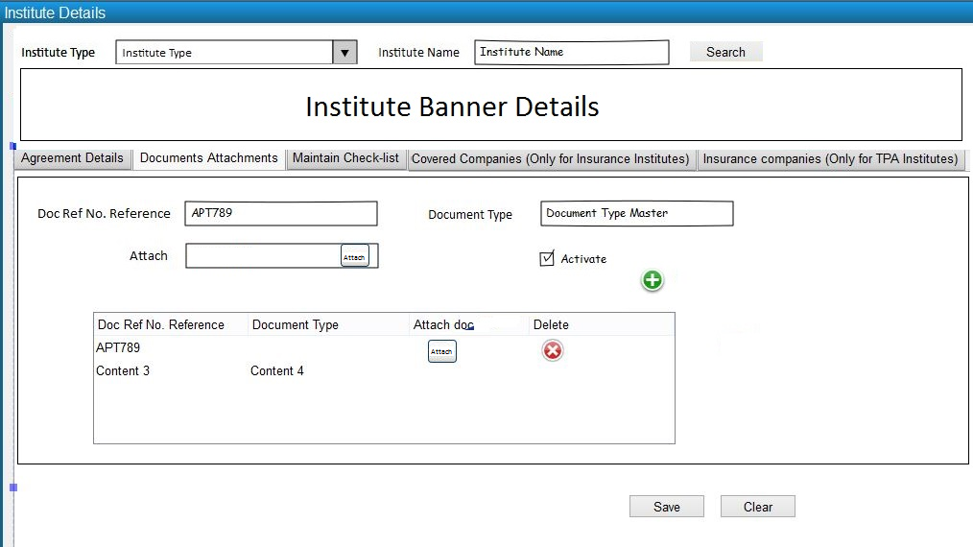
      - Screen Elements For capturing the Documents
Sr. no. | Field Name | Optional/  Mandatory | Description/  Explanation/  Formulae | Display/  Select /Enter | Source (Input) | Remarks  (Including Validation)
 | Doc Ref No. Reference | M | Reference number of the Document. | Enter | Nil
 | Document Type | M | Type of Document | Select | Document Type Master | Select from the drop down
 | Attach | M | Attach the document by selecting through the file selection dialog | Select | Nil
 | Active Indicator | M | Agreement active /inactive | Select | Yes/No | Nil
 | Add | M | Add multiple documents | Select | Nil

    - UI Framework for Covered Companies under the institute type INSURANCE
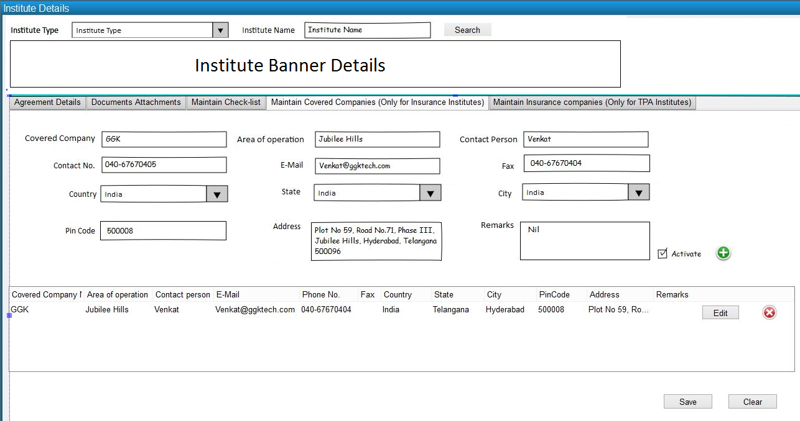
    - Screen Elements For capturing the covered companies under the institute type INSURANCE
Sr. no. | Field Name | Optional/  Mandatory | Description/  Explanation/  Formulae | Display/  Select /  Enter | Source (Input) | Remarks  (Including Validation)
 | Covered Company Name | M | Name of the Institute covered under the insurance | Enter | Nil | As per the list given by the insurance Institute
 | Address | O | Address of the covered Institute | Enter | Nil | Nil
 | Country | M | Self Explanatory | Enter | Nil | Nil
 | City | M | Self Explanatory | Enter | Nil | Nil
 | Phone Number | M | Self Explanatory | Enter | Nil | Nil
 | Website | O | Self Explanatory | Enter | Nil | Nil
 | Contact Person Name | O | Self Explanatory | Enter | Nil | Nil
 | Area of operation | O | Self Explanatory | Enter | Nil | Nil
 | Contact No. | M | Self Explanatory | Enter | Nil | Nil
 | Email Id | M | Self Explanatory | Enter | Nil | Nil
 | Fax | O | Self Explanatory | Enter | Nil | Nil
 | Remarks | O | Self Explanatory | Enter | Nil | Nil
 | Status indicator | M | Active /Inactive | Select | Yes/No | Nil
 | Print | O | Self explanatory | Select | Nil | Bar code

    - U I Framework for Insurance Companies under the institute type TPA
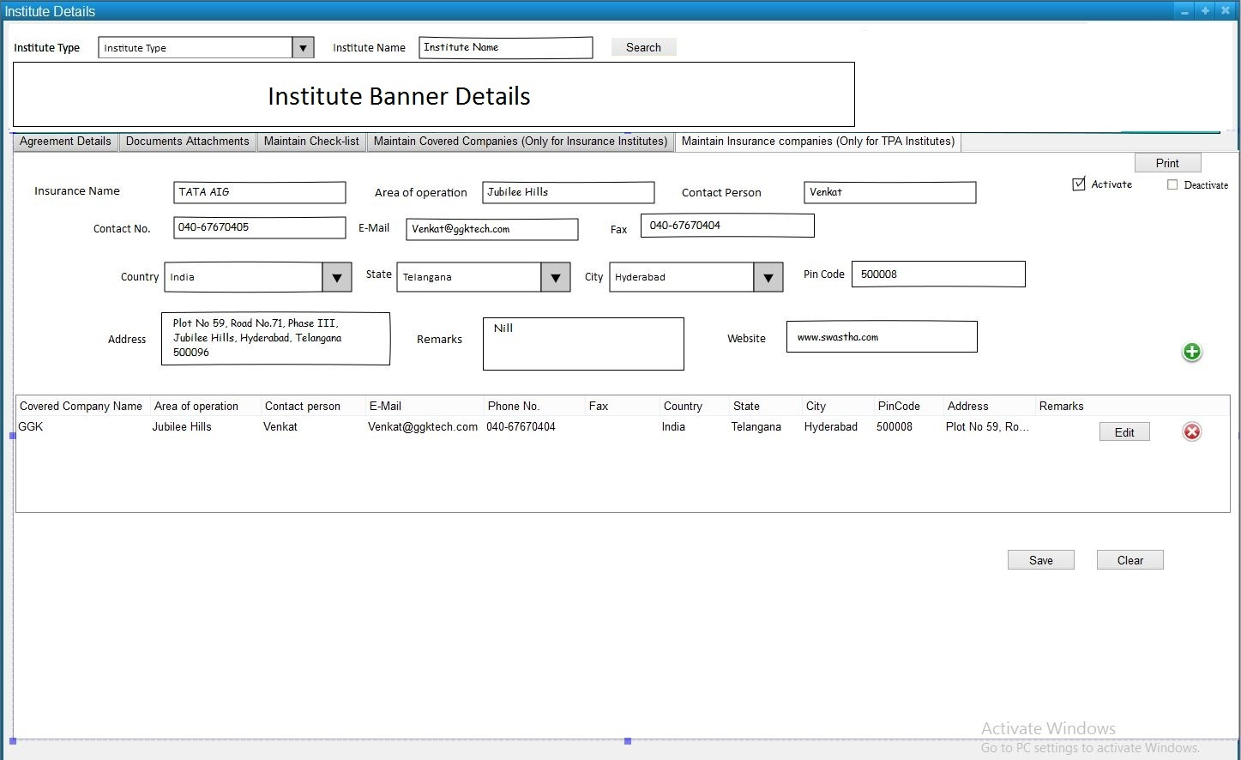
    - Screen Elements For capturing the Insurance companies under the institute type TPA
Sr. no. | Field Name | Optional/  Mandatory | Description/  Explanation/  Formulae | Display/  Select /  Enter | Source (Input) | Remarks  (Including Validation)
 | Insurance Name | M | Name of the Insurance company under the TPA | Enter | Nil | As per the list given by the TPA Institute
 | Address | O | Address of the Insurance Company | Enter | Nil | Nil
 | Country | M | Self Explanatory | Enter | Nil | Nil
 | City | M | Self Explanatory | Enter | Nil | Nil
 | Phone Number | M | Self Explanatory | Enter | Nil | Nil
 | Website | O | Self Explanatory | Enter | Nil | Nil
 | Contact Person Name | O | Self Explanatory | Enter | Nil | Nil
 | Area of operation | O | Self Explanatory | Enter | Nil | Nil
 | Contact No. | M | Self Explanatory | Enter | Nil | Nil
 | Email Id | M | Self Explanatory | Enter | Nil | Nil
 | Fax | O | Self Explanatory | Enter | Nil | Nil
 | Remarks | O | Self Explanatory | Enter | Nil | Nil
 | Status indicator | M | Active /Inactive | Select | Yes/No | Nil
 | Print | O | Self explanatory | Select | Nil | Bar code

    - UI Framework for Capturing Check List Details
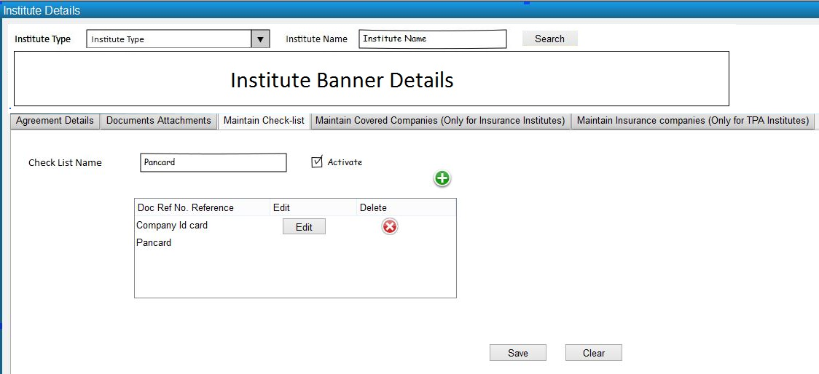
    - Screen Elements For capturing checklists

Sr. no. | Field Name | Optional/  Mandatory | Description/  Explanation/  Formulae | Display/  Select/  Enter | Source (Input) | Remarks  (Including Validation)
 | Check List Name | M | The check list item will be entered  e.g.  letter from the Institute  Id card etc | Enter | Nil | Nil
 | Status indicator | M | Active/inactive | Select | Yes/No | Nil
 | Display Order | O | Self explanatory | Enter | Nil | Nil

Maintain the Institute Tariff Definition

Description
The function is to define the tariff for the services and beds that the hospital provides to the patients. User can map the billing classes of the hospital and the company, and define the price of the agreed services and beds.

Pre-conditions
The Institute’s tie up status should be confirmed.

Main Flow
      - The user will select the institutes whose tie-up status is confirmed.
      - The screen will have 2 tabs, one for defining the service tariff and the other is to define the bed tariff.
Service Tariff Definition
      - Upon selecting the Institute, system will automatically display the institute details
      - In the Map Billing Class section, system will display the Hospital billing classes. Corresponding to each Hospital Billing Class, the Institute Billing Class will be entered.
      - By default the Institute Billing Class will be same as Hospital Billing Class, if user wishes to change the name of the Institute Billing Class the same can be done.
      - Upon defining the billing classes, on click of the Map button, system will create the map of the classes between the hospital and Institute.
      - The Institute billing class name appears in the service tariff definition table.
      - User will now be able to define the service tariff by selecting:
        - Service: User when clicks search in the Service field, then system will display all the services defined in the service master. Upon choosing the service, the selected service will be displayed in the tariff definition table. User should be able to multi-select the services
        - Service Type: User when clicks search in the Service Type field, then system will display all the service types from the master, for the selected service types if the user clicks add button, then all the services for the selected service types will be added to the tariff definition table.
After the selection of the service types if the user searches for the services, then system to display the services for the selected service types.
        - Section: User when clicks search in the Section field, then system will display all the sections from the master, for the selected sections if the user clicks add button, then all the services for the selected sections will be added to the tariff definition table.
After the selection of the sections if the user searches for the services, then system to display the services for the selected sections.
        - Department: User when clicks search in the Department field, then system will display all the departments from the master, for the selected departments if the user clicks add button, then all the services for the selected department will be added to the tariff definition table.
After the selection of the department if the user searches for the services, then system to display the services for the selected department. Similarly if the user selects sections, the sections of the selected department will be displayed for selection.
        - Add On or Reduce: For the services that are added to the service tariff definition table, if the user wants to modify the tariff by add-on or reduce amounts / percentage, then the same can be achieved through the respective fields. This can be applied for all classes or individual classes.
Bed Tariff Definition
      - On the load of the screen, system will display the table with the patient Billing Classes and the Bed Billing Class Tariff Matrix.
      - By default the matrix will be filled with the hospital bed tariff, user will be able to change the same if required.
Save
      - Upon save, the details are to be saved
The field elements for the tabs are given below.
      - UI Framework for Service Tariff Definition
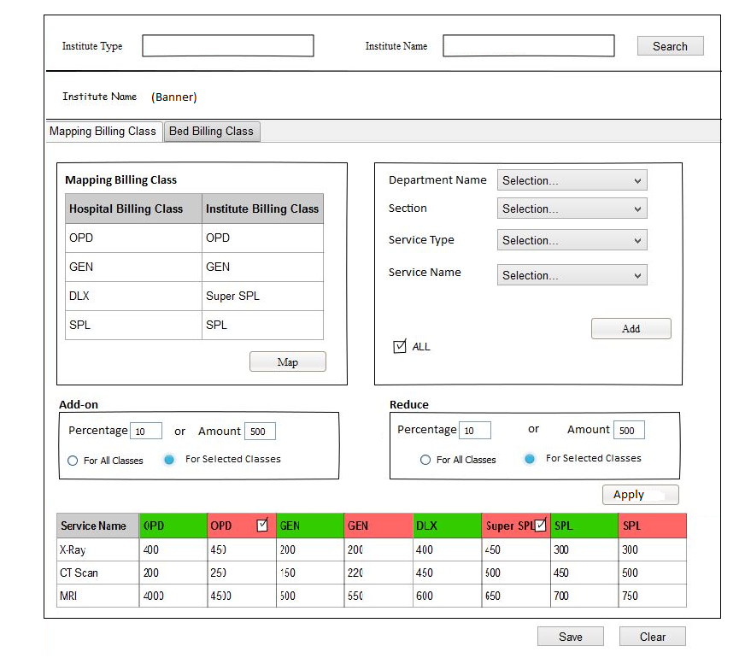
      - Screen Elements For capturing Service Tariff Definition
Sr. no. | Field Name | Optional/  Mandatory | Description/  Explanation/  Formulae | Display/  Select / Enter | Source (Input) | Remarks  (Including Validation)
 | Mapping Billing Class
 | Hospital Billing Class | O | Billing Classes of the Hospital | Select | Billing Class Master | Here user can select Hospital Billing class one by one.
 | Institute Billing Class | O | Institute Billing Class | Enter | Nil | Here user can enter desire billing Class applicable for the Institute. By default hospital bill class will be displayed
 | Map | M | Mandatory if Institute Billing Class is captured. | Select | Screen Icon | On selection of Icon system will Populate the Institute Billing class against Hospital billing Class with hospital tariff in different columns.
 | Department Name | O | The department/s for, which the services are defined will be listed | Select | Department Master & Service Master | Can include Single / multiple / All departments
 | Section Name | O | The section/s for, which the services are defined will be displayed. | Select | Section master & Service Master | Selection for Single / multiple / All sections is required.
 | Service Type | O | The Service Type/s for, which the services are defined will be displayed. | Select | Service Type Master and Service Master | Selection for Single / multiple / All Service Types is required.
 | Service Name | O | Service/s name for whom the tariff to be entered | Select | Service Master | Selection for multiple services is required.
 | Add details | O | Add the details | Select | Nil | Allow to add all the services under the selected criteria the list.  When no Department or Service Type or Section or Service is selected and Add button is clicked then allow to add all the active services to the list. System to prompt the user in such a case before adding all the services.
 | Add On % | O | Add on percentage | Enter | Nil | On entering the add on percentage for each billing class the percentage will be calculated on the hospital tariff and will be applied to the corporate equivalent billing class services.  When add on % is entered, then user should not be able to enter the Reduce %.  System should Round off the Rates based on marked rate defined in hospital Rules. For example if the rule is defined as to round off till 50 paisa. Then if the service after calculation comes 5.35 then system should round off the amount into 5.50.
 | Reduce % |  | Reduce percentage on the hospital tariff | Enter | Nil | On entering the reduce percentage for each billing class, the percentage will be calculated on the hospital tariff and will be applied to the corporate equivalent billing class services.  When reduce % is entered, then user should not be able to enter the Add on %, explained in the above point.  System should Round off the Rates based on marked rate defined in hospital Rules. For example if the rule is defined as to round off till 50 paisa. Then if the service after calculation comes 5.35 then system should round off the amount into 5.50.
 | Copy Tariff from Other Institute | O | Option to copy Tariff of other Institute to current Institute | Select | Screen Icon | On selection of The Icon system should populate the Institute List.  System should allow user to edit the Institute Billing Class Header after copying the same from Other Institute.

      - UI Framework for Bed Tariff Definition
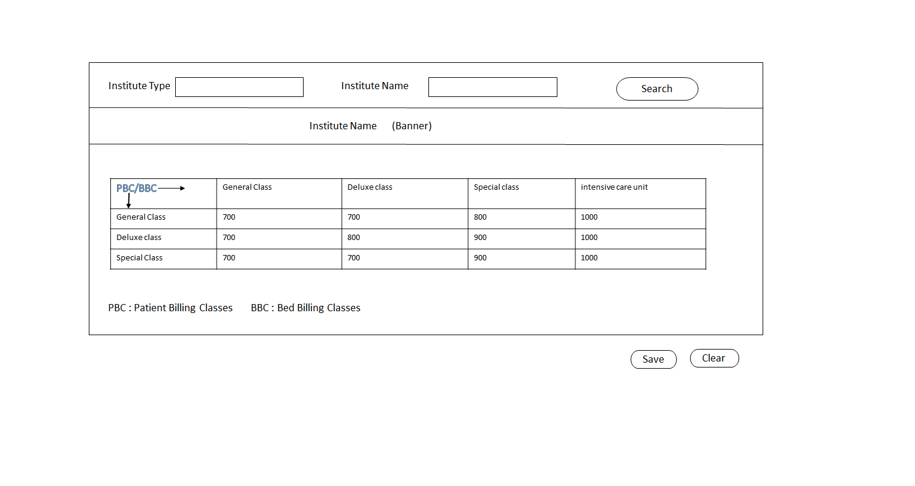
      - Screen Elements for Bed Tariff
Sr. no. | Field Name | Optional/  Mandatory | Description/  Explanation/  Formulae | Display/  Select /  Enter | Source (Input) | Remarks  (Including Validation)
 | Matrix
 | Patient Billing Class | M | The first column displays the Patient Billing Classes | Display | Billing class master | The billing classes that are mapped with the institute will be displayed
 | Column2 Header Onwards | M | Hospital bed Billing Class | Display | Hospital Bed Billing Class
 | Matrix | M | For each combination of the Patient and bed billing class the amounts as per the hospital bed charge matrix will be displayed | Display / Enter | Hospital Bed Charges | Use can change the amounts

Institute Wise Service Codes

Description
The function is to define the service codes and service descriptions as per the institute requirement that will be mapped to the hospital service codes. The mapped codes will be used in the bills, where the service name will be displayed as per the mapped service codes and description here.

Pre-conditions
  - The Institute’s tie up status should be confirmed.
  - Hospital services are defined

Main Flow
      - User will select the corporate / TPA / insurance Institute.
      - The user will select the enlisted / Pre-existed Departments and press List button.
      - System will display all the services linked with the department with service code and description in Service Code, Service Name.
      - Here user will enter the new code and description in the new fields Institute Service Name and Institute Codes for Mapping.
      - Once User will save the transaction system will display only the Mapped Codes and description in the bills related to the Institute.
      - There is a provision to copy the Codes and Description from Other Pre-mapped Institute also.

UI Framework for Institute wise service codes

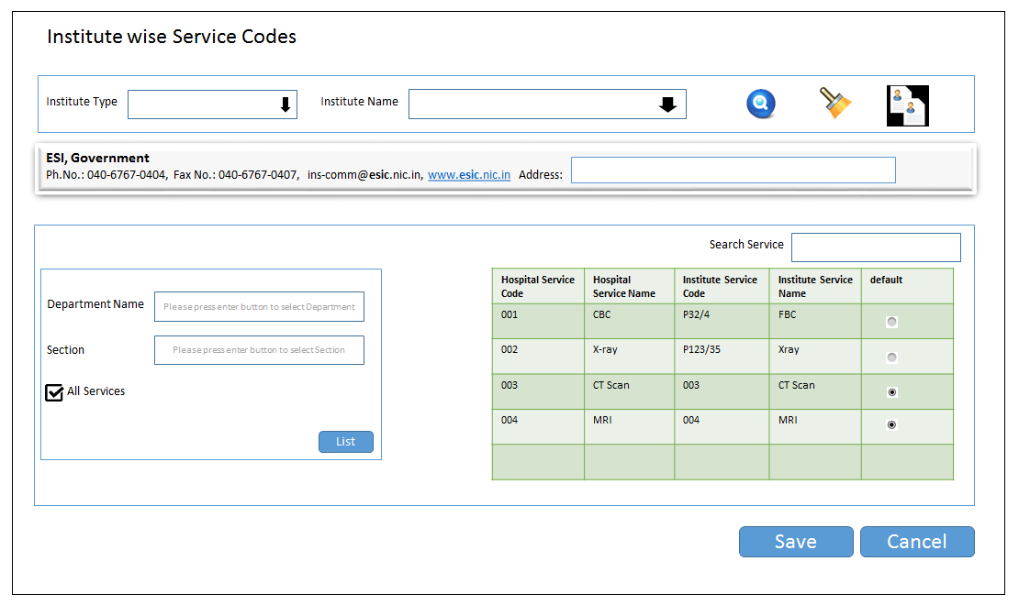

Screen Elements For capturing institute wise Service Codes

Sr. no. | Field Name | Optional/  Mandatory | Description/  Explanation/  Formulae | Display/  Select/  Enter | Source (Input) | Remarks  (Including Validation)
 | Institute Search
 | Institute Type | O | Lists the Institute types | Display / Select |  | If user selects the Institute name then the type to be displayed.  I
 | Institute Name | M | Select all Active Institute / Insurance Institute | Select | Institute Record | Nil
 | Search |  |  | Select
 | Clear
 | Institute Banner
 | Banner Details
 | Copy From Institute
 | Institute Type
 | Institute Name
 | Copy
 | Services Filter Criteria
 | Departments | O | Lists all the Departments for which the services are defined | Multi Select | Service Master and Department Master | To display all the departments
 | Sections | O | If departments are selected above then, system should list all the sections for the selected departments.  If the departments are not selected, then display all the sections for which the services are selected | Multi Select | Service Master, Department Master and Section master | To display all the sections
 | All Services | O | Check box | Select | Nil | If user checks this, and clicks the List button, system to display all the services, irrespective of the selection of the departments or services
 | List | NA | This will be enabled only if the departments are selected in the list OR  The sections are selected  OR  If all services is checked | Button | Nil | On click of this system to display all the services in the Link Services Table
 | Link Service Codes
 | Search Service | O |  | Enter |  | User should be able to search a service from the grid
 | Services grid
 | Service Code | M | Displays the hospital service code | Display | Service Master | Display all the services based on the selection criteria
 | Service Name | M | Displays the hospital service name | Display | Service Master | Display all the services based on the selection criteria
 | Institute Service Code | O | The Institute Service code will be entered | Enter | Nil | If the Institute wants to specify a separate code for the service, the same will be entered
 | Institute Service Name | O | The Institute’s Service Name will be entered | Enter | Nil | If the Institute wants to specify a separate name for the service, the same will be entered
 | Default | O | Button | Select | Nil | On click of this the system should default the hospital service code and name to the institute service code and name
 | Confirm
 | Save
 | Clear

  - Capture Entitlement details

Description
      - For a defined Institute, the entitlements will be defined here.
      - Each Institute can have unlimited entitlements.

Pre-conditions
      - The Institutes are created.

Main Flow
      - User will select the Institute.
      - For the selected Institute, user will enter the Entitlement name
      - System will then enable to capture the following details:
        - General Details
        - Entitlement Details
        - Panel Doctors
        - Remarks
        - Diagnosis Exclusions
      - The field elements for both the sections are given below.

    - UI Frame Work For Creating a new entitlement for Institute / Insurance / TPA
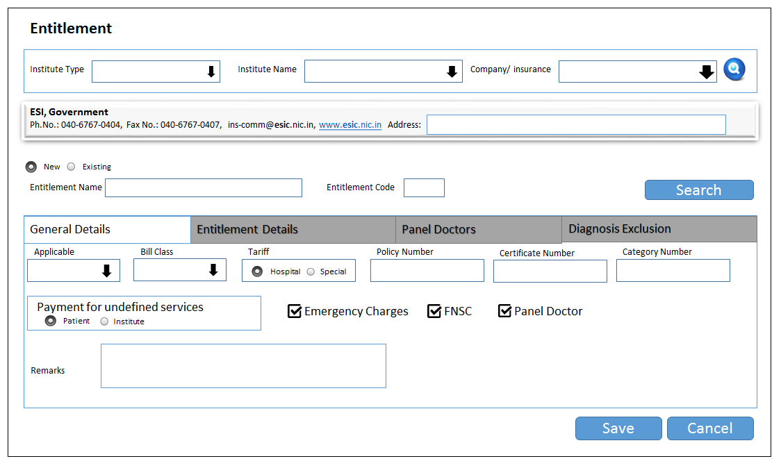

    - UI Frame Work For capturing the entitlement details
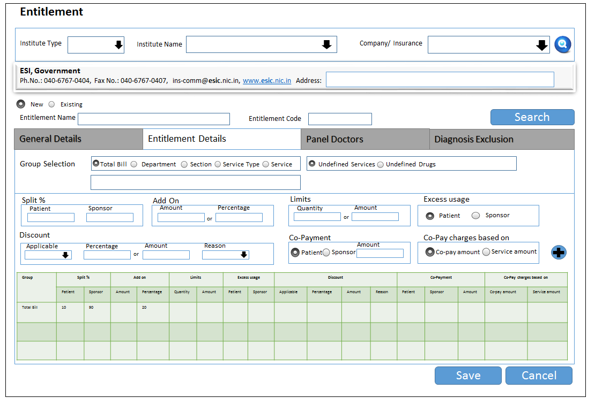

    - UI Frame Work For Capture Panel doctor for each entitlement
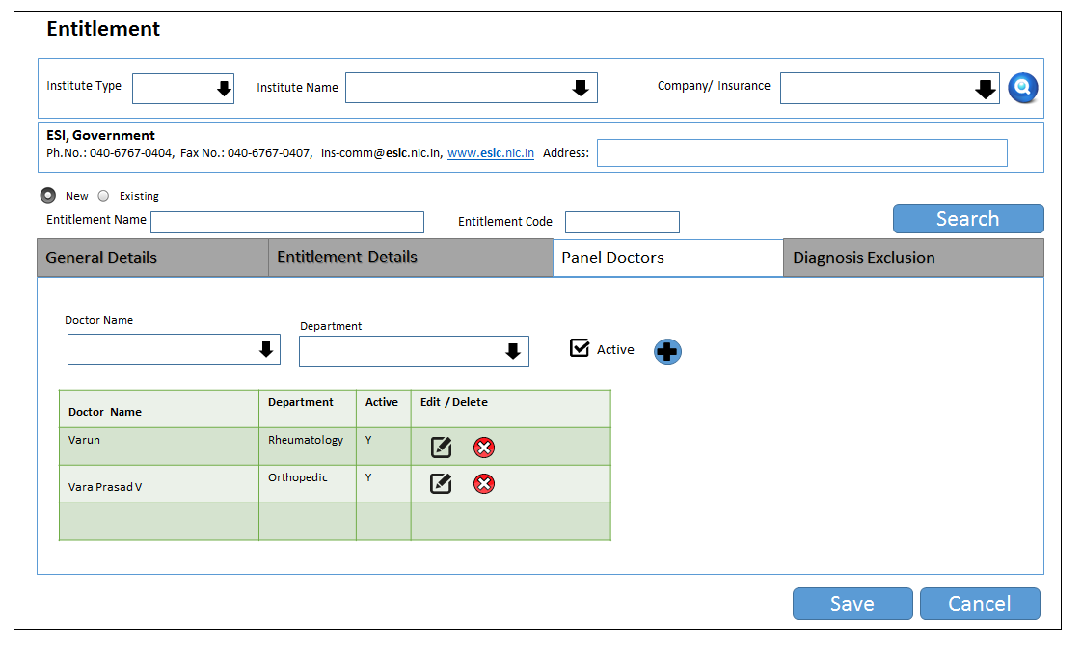

    - UI Frame Work For Capture entitlement Diagnosis Exclusion
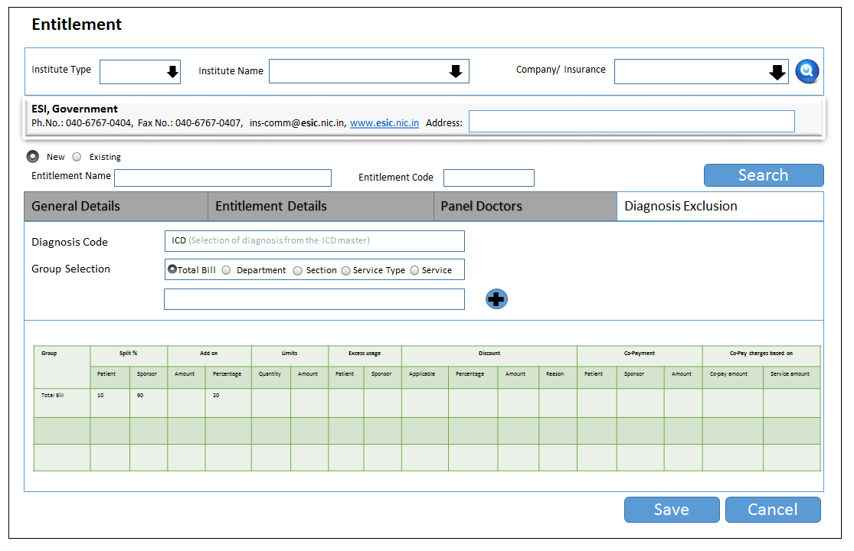

    - Screen Elements For Capturing General Entitlement Details

Sr. no. | Field Name | Optional/  Mandatory | Description/  Explanation/  Formulae | Display  /Select /  Enter | Source (Input) | Remarks  (Including Validation)
 | Institute type | M | TPA/Insurance/Corporate | Select | Institute type
 | Institute Name | M | Name of the Institute | Select | Tie up details | If the selected institute is Insurance then point 3 below will be enabled  If the selected institute is a TPA then point 4 will be enabled  Else both 3 and 4 will be disabled
 | Covered Company | M | Institutes covered under the insurance | Select | Institute details | Nil
 | Covered Insurance | M | Institutes covered under the TPA | Select | Institute details | Nil
 | Entitlement Name | M | The name of the entitlement | Enter | Nil | As per the list provided by the Institute
 | Entitlement Code | M |  | Enter | Nil | Abbreviation code
 | General Details
 | Entitlement applicable | M | Whether the entitlement is applicable to  OP or IP or Both | Select | Predefined parameters | Select the entitlement applicable for OP or IPD or Both.
 | Billing Class | M | The corporate billing classes | Select | Billing class records | If Institute billing classes are applied then the defined entitlement should be applied to the selected class at the time of admission. There Should be a provision to select multiple Billing class.
 | Tariff based On
 | Hospital Tariff | O / M | Hospital Tariff | Select | Radio Button | Selection of this parameter will apply the hospital tariff for given entitlement. It will overwrite the specially defined Tariff.
 | Special Tariff | O / M | Specially defined Tariff for the institute | Select | Radio Button | Selection of this parameter will apply the Special tariff for given entitlement. It will overwrite the Hospital Tariff.
 | Payment for Undefined Service
 | Patient | O / M | Self explanatory | Select | Radio Button | Selection of this parameter will enable System to Charge for all undefined services in entitlement to Patients
 | Institute | O / M | Self explanatory | Select | Radio Button | Selection of this parameter will enable System to Charge for all undefined services in entitlement to Institute
 | Foreign National Surcharge (FNSC) | O |  | Select | Check Box
 | Emergency Charges | O |  | Select | Check box
 | Panel Doctor | O | Self Explanatory | Select | Check box | It will enable entry of panel doctor tab, which will become mandatory to enter.
 | Policy Number | O | Policy number provided by the insurance or the TPA. | Enter | Nil | Display in credit memo.  Only for Insurance and TPA
 | Certificate Number | O | Certificate Number of the policy provided by the insurance or the TPA | Enter | Nil | Display in credit memo.  Only for Insurance and TPA
 | Category Number | O | Category Number of the policy provided by the insurance or the TPA | Enter | Nil | Display in credit memo.  Only for Insurance and TPA
 | Networks | O | List of network hospitals | Enter | Nil | Capture the list of network hospitals, where the policy can be availed by the patient.  Display in credit memo
    - Screen Elements For Capturing The Entitlement Details

Sr. no. | Field Name | Optional/  Mandatory | Description/  Explanation/  Formulae | Display/  Select /  Enter | Source (Input) | Remarks  (Including Validation)
 | Group Selection Criteria
 | Group Selection | M |  | Select | Group Master | The system will display the Group based on the filter selected like  - Total Bill  - Department  - Section  - Service Type  - Service  There should be a provision to select Single / Multiple / All based on filter selected.
Total Bill: When this group is selected, user should be able to enter the split percentage and discounts.

If any exclusion is entered for drugs and services, the same should be captured and system should calculate the bill excluding the same. The Exclusion Tab will be appeared only if the Total Bill will be selected in Group. System should not allow user to add any other group once Total Bill is already selected in the same screen. Please Refer 3.8.11 for exclusion Details.

All Departments: When this sub group is selected, user should be able to enter the split percentage and discounts. Individual procedure / section / department selection ability should be restricted.

All Drugs: When this sub group is selected, user should be able to enter the split percentage and discounts. Individual drug group/ drug selection ability should be restricted.

Individual Service: When this sub group is selected provision to select the individual services from the service master should be provided. For the selected service the split percentage and discounts can be captured. Provision to capture Co-payments and limits (in quantity or amount) should be provided.

Individual Section: When this sub group is selected provision to select the individual section from the section master should be provided. For the selected section the split percentage and discounts can be captured.

Individual Drug Group: When this sub group is selected provision to select the individual drug groups from the product group master should be provided. For the selected group the split percentage and discounts can be captured.

Individual Drug: When this sub group is selected provision to select the individual drug from the product master should be provided. For the selected drug the split percentage and discounts can be captured. Provision to capture Co-payments and limits (in quantity or amount) should be provided.

 | The order for defining the Exclusion / Inclusion / Split of services should follow given Hierarchy | The User should able to add any group criteria at any point of time.  But the system should check at least level like Individual Service level → Individual Service Type → Individual Section level → Individual Department level → Total Bill Level.  The Drug Group and Drug group can be deferred at this point of time as there is no Product master.
 | Sponsor Split % | M | Self Explanatory | Enter (%) | Nil | The sponsor split percentage cannot be less than 0 and more than 100. On entering the sponsor split % the patient split percentage should calculated.
 | Patient Split % | M | Self Explanatory | Enter (%) | Nil | The patient split percentage cannot be less than 0 and more than 100. On entering the patient split % the sponsor split percentage should calculated.
 | Add On (Either Amount or percentage can be entered)
 | Amount | O | Self Explanatory | Enter |  | The Add on Amount will be used to add extra charges in Amount against selected Department or Service Type / Section / Service.
 | Percentage | O | Self Explanatory | Enter |  | The Add on Amount will be used to add extra charges in Percentage against selected Department or Service Type / Section / Service.
 | Discounts
 | Discount % | O | Self Explanatory | Enter (%) | Nil | Either discount amount or % is allowed.  The percentage of discount applicable to patient or sponsor or both. It should follow the Discount rules (Calculation Before or after in case of Split Bill)
 | Discount Amount | O | Self Explanatory | Enter | Nil | Either discount amount or % is allowed.  The amount of discount applicable to patient or sponsor or both. It should follow the Discount rules (Calculation Before or after in case of Split Bill)
 | Discount  Reason | M | Self Explanatory | Select | Discount Type Master | If user is adding Discount then the Discount Reason will be mandatory
 | Discount Applicable to | M | Applicable to one of the below:  - Only To Patient  - Only To Sponsor  - Both | Select | Yes /No | Based on the selection the discount will be applied to the patient or sponsor or both.
 | Limits (Either amount or quantity can be entered not both)
 | Amount Limit | O | For the selected procedure or drug, the amount limit is captured | Enter | Nil | Certain services or drugs can have an amount limits. At the time of calculating the bill, this limit should be applied accordingly.
 | Quantity Limit | O | For the selected procedure or drug, the quantity limit is captured | Enter | Nil | The entered quantity for the service or drug will be validated at the billing time and the excess will be charged to patient or sponsor.
 | Co-payment
 | Co-payment | O | Patient / sponsor | Select | Yes /No | The co-payment can be either for patient or for sponsor. This should be applicable for an individual service only.  System should Display a Co -Payment Message during billing (only if the Co-payment rule applied on the voucher).
 | Co-payment amount | O | The amount to be entered for co-payment | Enter | Nil | The entered amount should be paid by the patient or sponsor as per the selection done above
 | If Co – Payment is greater than Service amount, Then the Charge should based on | O | The option is to determine the basis of service charging, if co payment is applied on any service. For example if the service rate is less than the co-payment then based on selected parameter system will post the charge. | Select | Predefined parameters | If the user selects Service then system should check service rate, even if the co – payment is more than the service rate and If Co – payment is checked then system should check Vice –Versa.
 | Pay of Excess usage | O | A provision to define the party, who is going to pay for the excess usage to Services. | Select | Predefined Parameters | Here the excess usage payer will be defined Either it will be Patient or sponsor.
 | Patient | O | Self Explanatory | Select | Radio Button | If patient is selected then he will pay for all the extra service whatever not defined in Entitlement.
 | Sponsor | O | Self Explanatory | Select | Radio Button | If Sponsor is selected then It will bear all the extra service whatever not defined in Entitlement.
 | Remarks | O | Need Remark Option In new Tab | Enter | Nil | Enter any Remark in a new TAB

    - Screen Elements For Panel Doctor Details
Sr. no. | Field Name | Optional/  Mandatory | Description/  Explanation/  Formulae | Display  /Select /  Enter | Source (Input) | Remarks  (Including Validation)
 | Doctor Name | M | Self Explanatory | Select | Doctor Master | Select doctor to add in the panel of that Institute
 | Add | O | Self Explanatory | Select | Screen Icon | Add the Doctor into the panel.
 | Clear | O | Self Explanatory | Select | Screen Icon | Clear the content

    - Screen Elements For Diagnosis Exclusion Details
Sr. no. | Field Name | Optional/  Mandatory | Description/  Explanation/  Formulae | Display  /Select /  Enter | Source (Input) | Remarks  (Including Validation)
 | Group Selection Criteria | M | The group selection should be for Departments / Service Type and Services | Select | Group Master | The system will display the Group based on the filter selected like  - Total Bill  - Department  - Section  - Service Type  - Service  There should be a provision to select Single / Multiple / All based on filter selected.
 | Group Selection | M | The sub group should be of the following types:  - Total Bill  - All Departments  - Individual Department  - Individual Sub Department  - All Drugs  - Individual Drug Group  - Individual Section  - Individual Sub section  - Individual Service  - Individual Drug | Select | Sub group Master | 1) The system will display the Group based on the filter selected like  If Department is selected then system should display following groups  - Total Bill  - All departments  - Individual Department  - Individual Sub department  - Individual Section  - Individual Sub Section  - Individual Service  2) If Service Type Will be selected the system should display following groups  - All Service Types  - Individual Main Service Type  - Individual Sub Service Type  - Individual Service  3) On selection of Individual Department / Sub Department / Section/ Sub Section / Individual Service / Individual Sub Service Type / Individual Main service Type, system should display all the Sections / Departments / Service Types / Main Service Types in Child window based on selection.  4) There should be a provision to select Single / Multiple / All based on filter selected.
 | Diagnosis Exceptions | M | Self Explanatory | Select | ICD Master (Diagnosis Master) | Selection of diagnosis from the ICD master
 | Add | O | Self Explanatory | Select | Screen Icon | User adds the groups which will be excluded.  The Added groups will be excluded at the time of billing if user selects the Diagnosis.

Queries

Institute wise tie ups

Selection criteria:
      - Date (from & to)
      - Mode of approach
      - Institute type – corporate/TPA/insurance Institute
      - Name of institute
      - State
      - Service ( Used to search populated services for a selected Institute)
      - Name of the contact person( institute)
      - Name of the contact person( hospital)
      - Charge (Check box, once Checked, System should display the Special Charges defined for the Institute once selected by User).

Display Criteria
      - Date
      - Mode of approach
      - Institute type – corporate/TPA/insurance Institute
      - Name of institute
      - State
      - Service
      - Billing Classes
      - Rates (Billing Class wise)
      - Name of the contact person ( institute)
      - Name of the contact person( hospital)
      - Here User will select Filters given in 4.1.1.1, 4.1.1.2, 4.1.1.3, 4.1.1.4, 4.1.1.5, 4.1.1.7, 4.1.1.8. Then system will display information according to selected Filters. If user select Charge Check box, System should display the Special Charges defined for the selected Institute.
      - Once the Institute details will be displayed on selection of it should display the Charge details.
      - The Search option should enable user to filter the service, which is displayed along with the rates after selection of the institute (displayed on the basis of selected Filters.)

  - Service type wise - tie ups details
    - Selection criteria
      - Date (from & to)
      - Mode of approach
      - Institute type – corporate/TPA/insurance Institute
      - Name of institute
      - Service type
      - Name of the contact person( institute)
      - Name of the contact person( hospital)
    - Display
      - Date
      - Mode of approach
      - Institute type – corporate/TPA/insurance Institute
      - Name of institute
      - Service type
      - Name of the contact person ( institute)
      - Name of the contact person( hospital)

Agreement Expiry Details

Selection criteria:
      - Date (from & to)
      - Agreement details expiry (between dates /days)
      - Institute type
      - Agreement No.

Display criteria:

  - Institute Wise Entitlement Details

    - Selection criteria:

    - Institute type
    - Institute name

    - Display criteria:

  - Panel Doctor Details

    - Selection criteria:

    - Date (from & to)
    - Institute type
    - Entitlement
    - Status (active/inactive/all)

    - Display criteria:

- Outputs
  - Corporate / Insurance / TPA Details
    - Selection Criteria
      - Institute type
      - Institute name
      - Date

    - Display Criteria

  - Corporate / Insurance / TPA Details
    - Selection Criteria
      - Institute type
      - Institute name

    - Display Criteria

- Processing Details:

  - After the Corporate and their entitlements are created, the same should be visible for the front office.
  - Only those institutes/entitlements that are active should be used

- Interface / Integration Details:

  - Registration – patient type
  - Admission - billing class admission
  - Billing
  - Credit control cell – tie up details
  - Finance - for charges, tariff
  - Customer service
  - Institute database- (for their details)
  - Smart card
  - Printer
  - SMS
  - E mail system

- Parameterization/Flexibility:

  - Specific:

    - Provision to define the multiple entitlements for each Institute / insurance / TPA.
    - Follow hospital tariff / Institute tariff for each entitlement.
    - Define OP limits in both quantity and amount at voucher level is required.
    - Apply emergency charges to the entitlement
    - Define exclusions, inclusions, co-payments and split payment
    - Define discounts to at group or subgroup level
    - Copy the details from other institutes(entitlement)
    - Define sponsor limits in quantity or amount at group and subgroup level
    - For Institute patients, the sale of drugs should be on cost price or on selling price or MRP.
    - Modify the tariff at an item level or for the entire selected services with an increased or reduced percentage, with an ability to round the net amount.
    - Provision to rename the service name and code as per the Institute
    - Each institute to have a single unique code (irrespective of the no. of branches).
    - For Co – Payment there should be provision to define the basis of Charging if the Co-payment is more than the Service Charge. Here User will have facility to choose whether it should base on Service Rate or Co Payment Rate. System should prompt the user whenever Co payment amount is more than the Service Amount.
    - System should have provision to define the rule of Discounts. There are two conditions under which discount will be calculated.
      - Before the Split of Charges between Party and Patient according to entitlement and
      - After the Split of Charges between Party and Patient.
      - System should provide an option to create such rules for discounts.
    - Rounding off of the tariff defined in the tariff definition according to the Markup defined in the Hospital Control / Platform Master.

  - General:

    - Flexibility to add/modify names of the fields defined as tax / “miscellaneous”.
    - Flexibility to incorporate and modify formulas for calculation of fields based on any reference field and/or in combinations and/ or cumulative output of reference fields as defined in formula.
    - Flexibility to mask the field/s which are defined as “miscellaneous” and are either:
      - NOT applicable OR
      - Where the tax amount/percentage is zero.
    - There should be flexibility of defining all the mentioned fields in this FSD as optional or mandatory.
    - Dynamic report feature to select any fields mentioned above in steps and generate report.
    - Facilities to convert all report into excel format or word format.
    - Flexibility to add number of recipients with different messages/email for the same trigger/activity.
    - Modifying fields of different combination of text, numeric, alphabet, character, record or symbol
    - All Query for reporting.
    - Option to send email and SMS to the concerned user(by default and option to change the default if the email and SMS are not be sent
    - Flexibility to have option of Modification parameters (Add/substitute/delete) in the various reports.
    - To allow or not allow multiple selections for the same pre- defined field across different modules.
    - While inputting data when a field is “Selected”, by default cursor should proceed to the next field for subsequent data entry.
    - Provision to print and scan the documents which have been proposed to be eliminated
    - Display User Id in all the reports

